POLITICAL JUGGERNAUTS: A QUANTATIVE ANALYSIS OF CANDIDATES IN THE LOK SABHA ELECTION

1.INTRODUCTION

1.1 OVERVIEW

The Lok Sabha, constitutionally the House of the People, is the lower house of India's bicameral Parliament, with the upper house being the Rajya Sabha. Members of the Lok Sabha are elected by an adult universal suffrage and a first-past-the-post system to represent their respective constituencies, and they hold their seats for five years or until the body is dissolved by the President on the advice of the council of ministers. The house meets in the Lok Sabha Chambers of the Parliament House, New Delhi.

The maximum membership of the House allotted by the Constitution of India is 552[3] (Initially, in 1950, it was 500.) Currently, the house has 543 seats which are filed by the election of up to 543 elected members. Between 1952 and 2020, two additional members of the Anglo-Indian community were also nominated by the President of India on the advice of Government of India, which was abolished in January 2020 by the 104th Constitutional Amendment Act, 2019.[4][5] The new parliament has a seating capacity of 888 for Lok Sabha.

A total of 131 seats (24.03%) are reserved for representatives of Scheduled Castes (84) and Scheduled Tribes (47). The quorum for the House is 10% of the total membership. The Lok Sabha, unless sooner dissolved, continues to operate for five years from the date appointed for its first meeting. However, while a proclamation of emergency is in operation, this period may be extended by Parliament by law or decree.

The Lok Sabha has certain powers that make it more powerful than the Rajya Sabha. Motions of no confidence against the government can be introduced and passed in the Lok Sabha. If passed by a majority vote, the Prime Minister and the Council of Ministers resign collectively

Powers. In the Indian federal structure, the Rajya Sabha is a representative of the states in the union legislature (hence the name, Council of States). For this reason, the Rajya Sabha has powers that protect the rights of states against the union government.

2. PROBLEM DEFINATIO AND DESIGN THINKING

2.1 EMPATHEY MAP

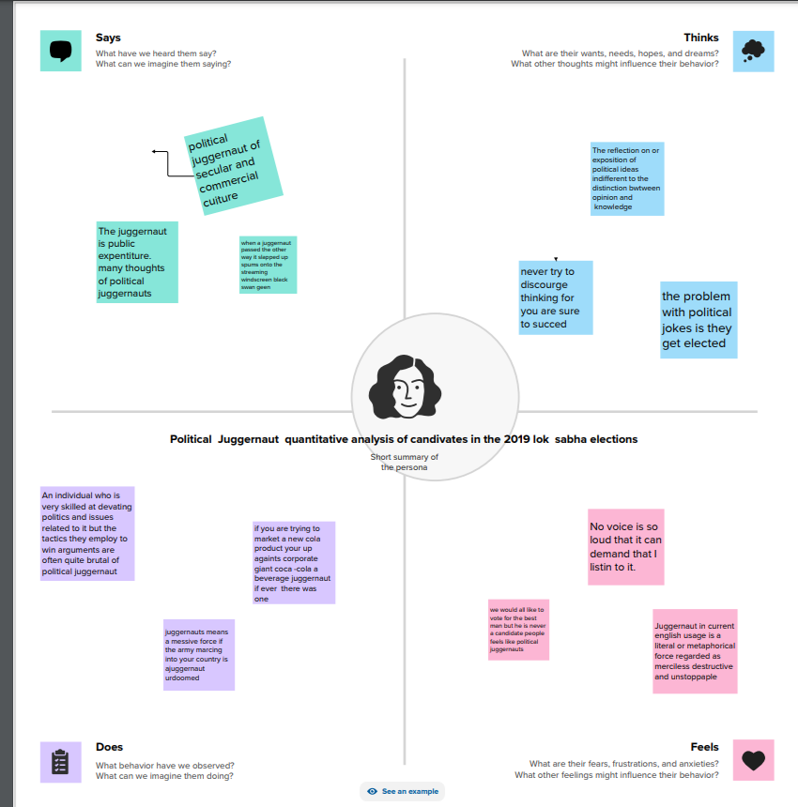

2.2 IDEATION AND BRAINSTORMING MAP

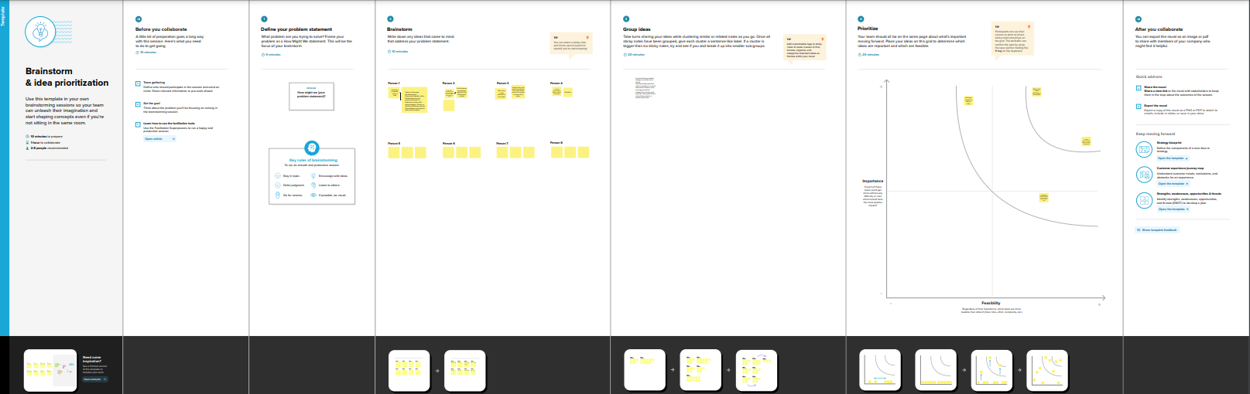

RESULT

DASHBOARD 1

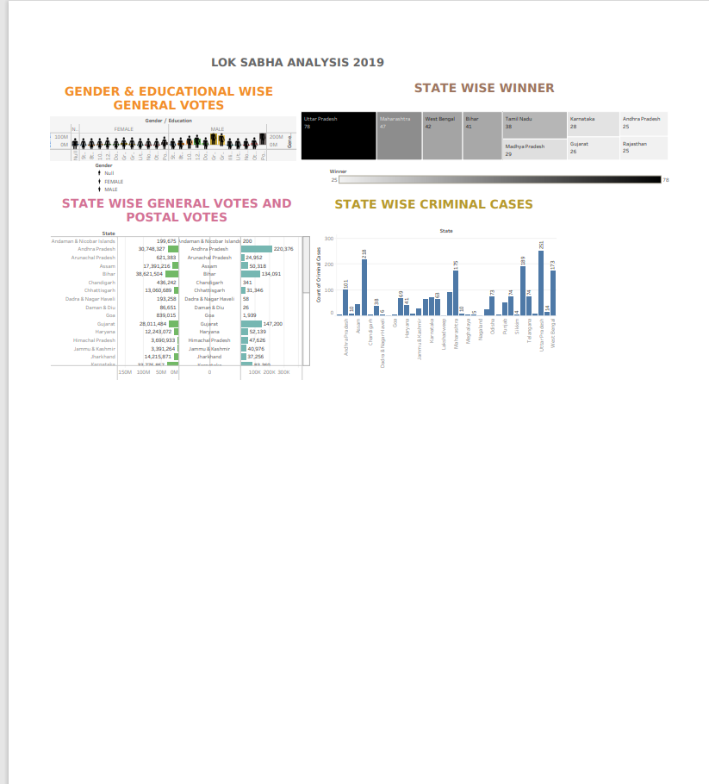

DASHBOARD 2

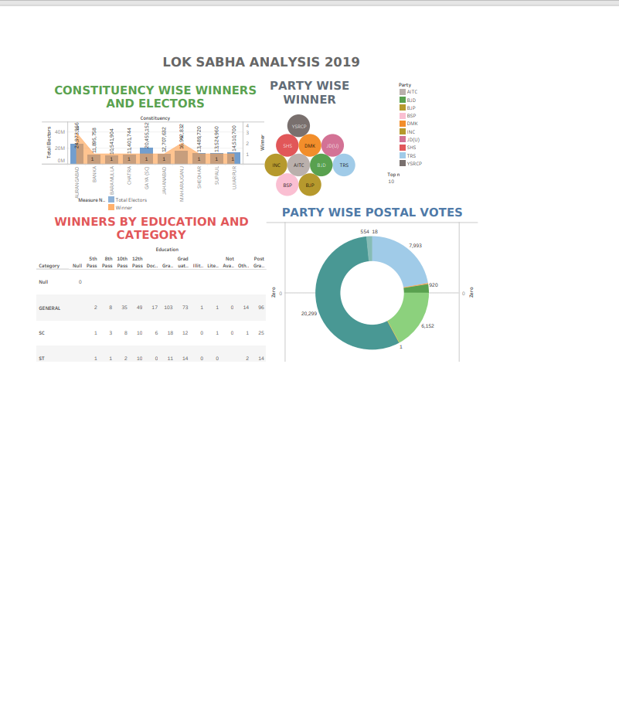

STORY

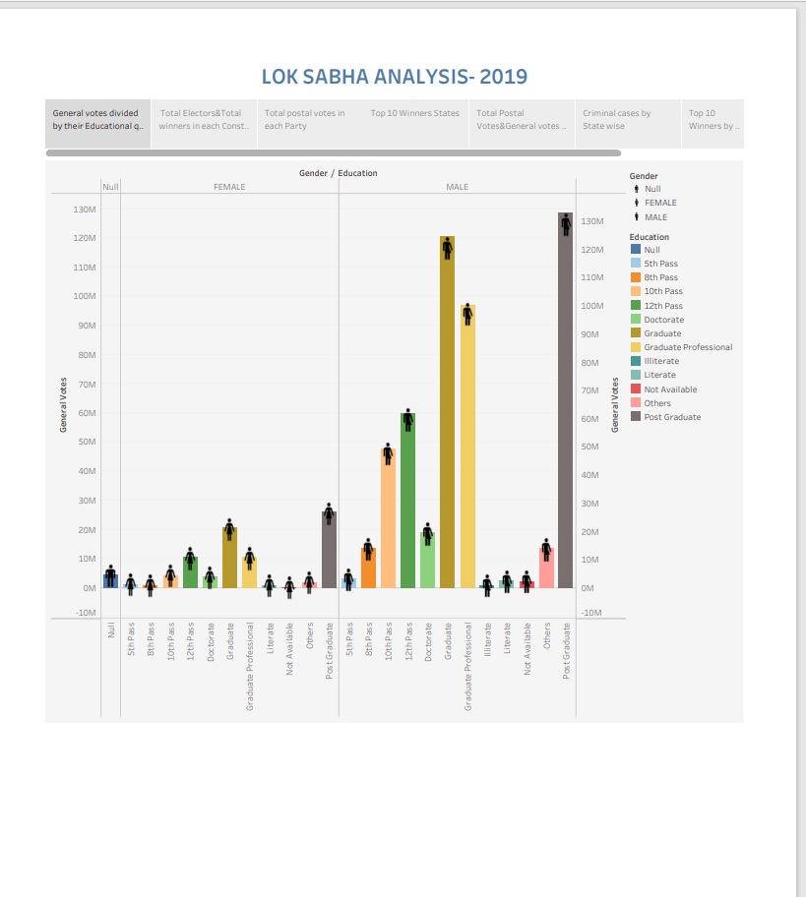

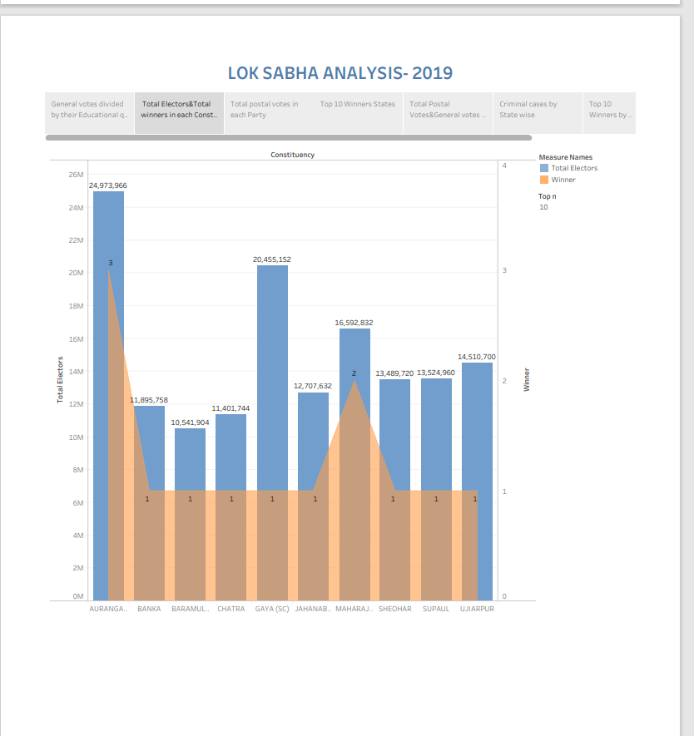

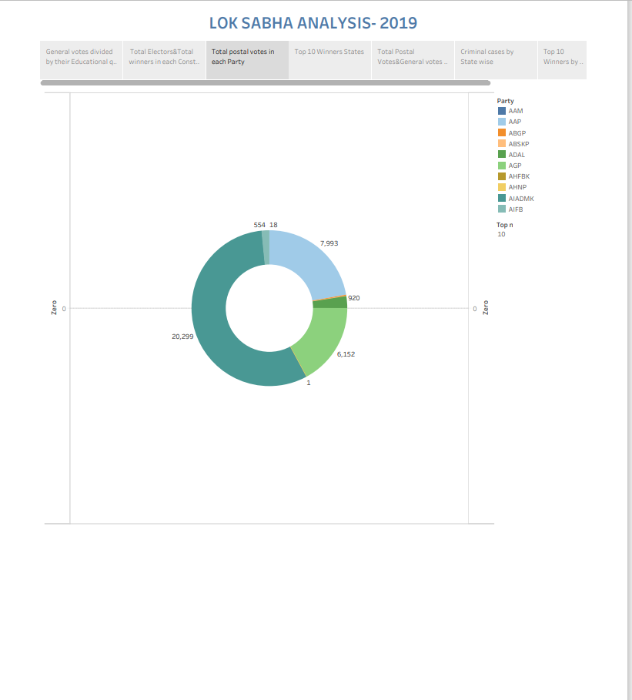

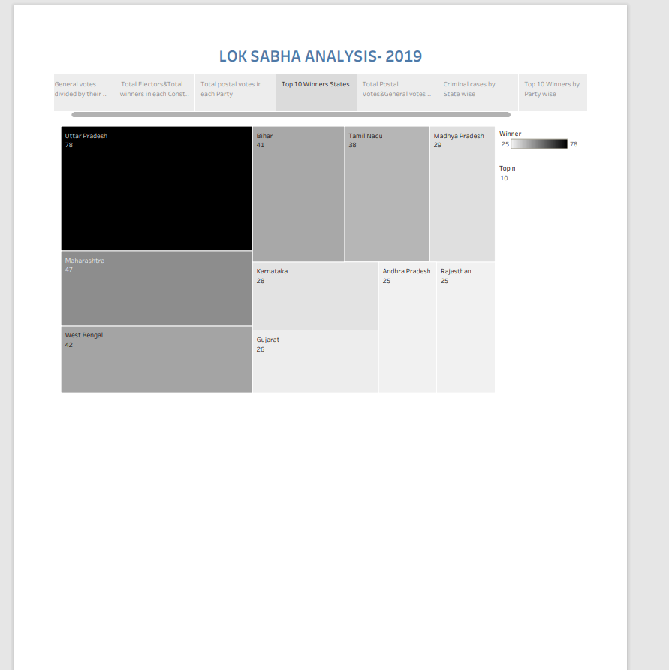

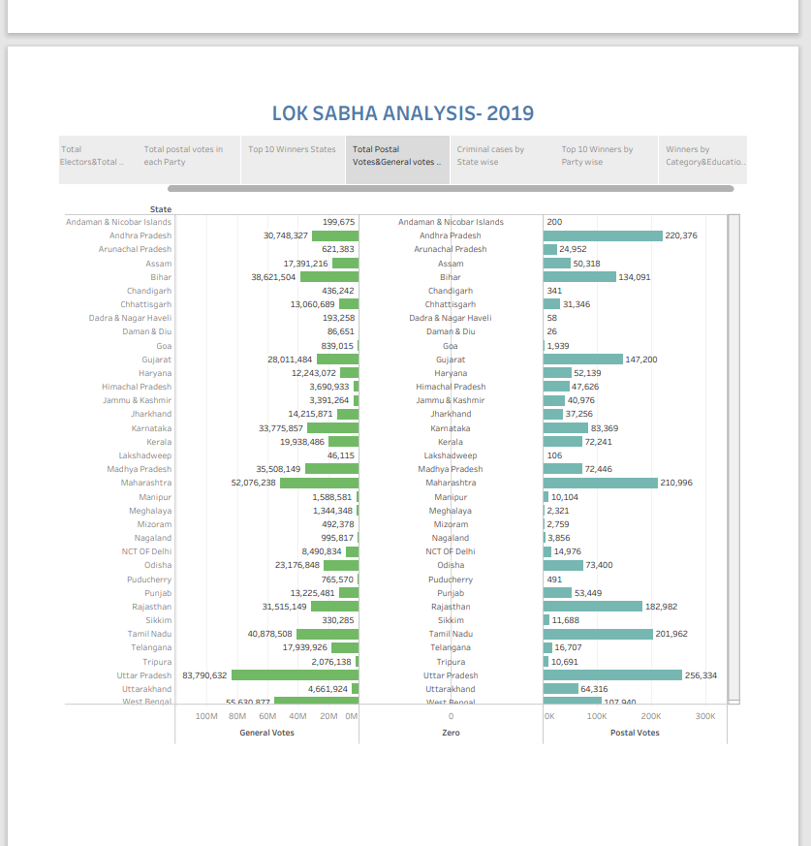

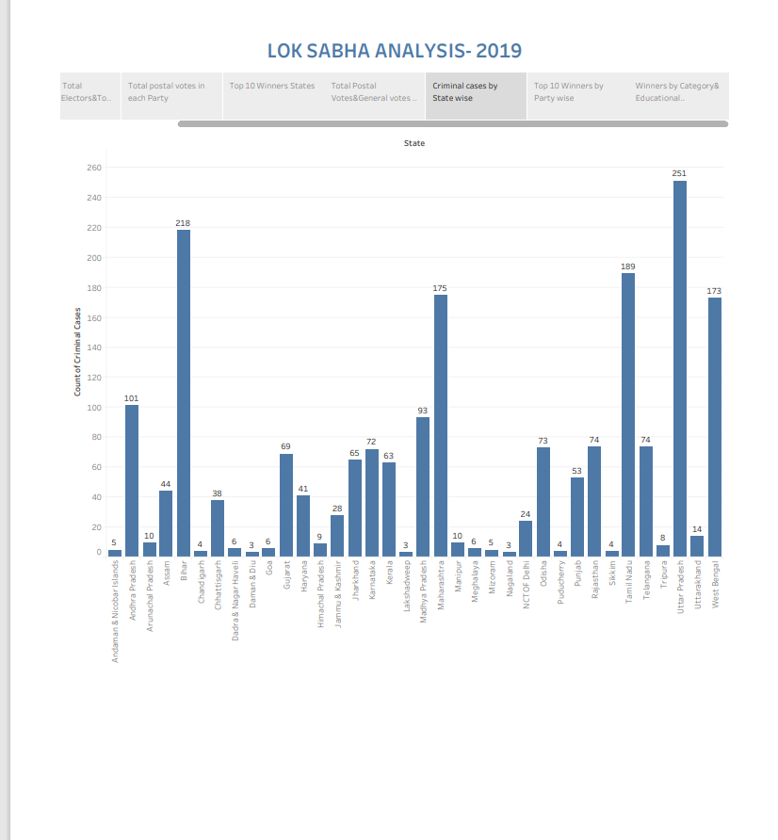

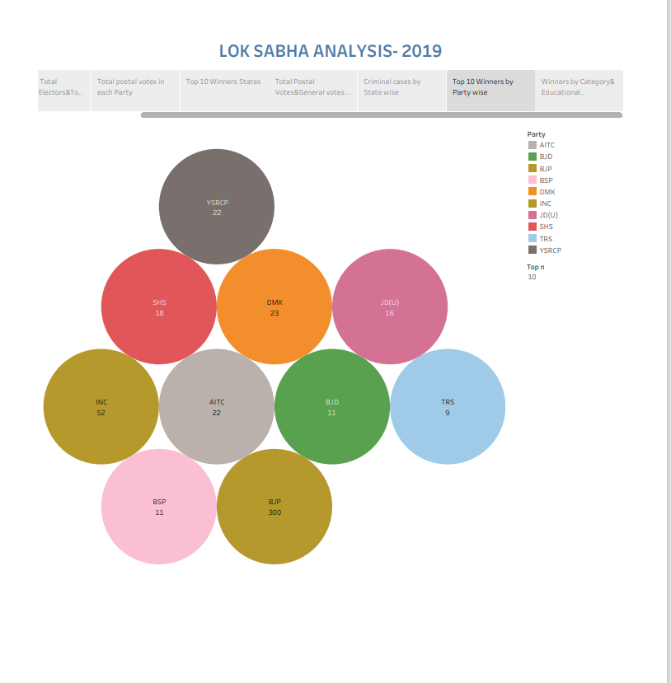

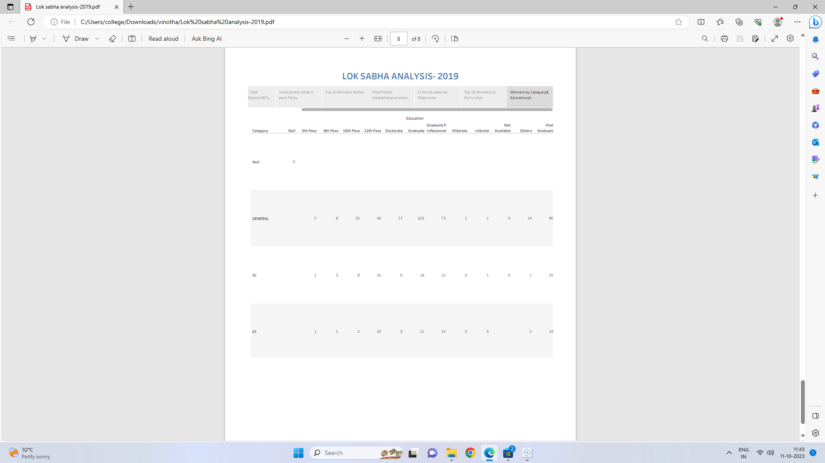

ADVANTAGES

1. The Lok Sabha is the popular House
2. Its members are directly elected by the people.
3. Another factor which makes the Lok Sabha more important than the Rajya Sabha is cabinet responsibility.
4. The members of the Council of Ministers at the centre are responsible to the Lok Sabha and not to the Rajya Sabha
5. In India, the Money Bill can be introduced only in the Lok Sabha; it cannot be introduced in the Rajya Sabha

DISADVANTAGES

1. There are some problems like disruption of the proceedings by Congress members and other members.
2. Members of the Lok Sabha often vote along party lines due to the strong influence of political parties and the whip system.

APPLICATION

General elections were held in India in seven phases from 11 April to 19 May 2019 to elect the members of the 17th Lok Sabha. Votes were counted and the result was declared on 23 May.[1][2][3][4] The election resulted in a landslide victory for the BJP which won 303 seats and formed the government.

CONCLUSION

In conclusion, the Lok Sabha is more powerful than the Rajya Sabha in almost all matters. Even in those matters in which the Constitution has placed both Houses on an equal footing, the Lok Sabha has more influence due to its greater numerical strength.